**ATHARVA COLLEGE OF ENGINEERING**



**IOT Mini Project Report**

**on**

“OBSTACLE DETECTION”

Team Members:

1. Abhijit Turate-70
2. Priyanka Shinde-71
3. Kesha Mehta-74

**(Third year IT Department)**

Under the guidance of

**Prof. Nileema Pathak**

**Prof. Pranoti Nage**

ATHARVA COLLEGE OF ENGINEERING

**CERTIFICATE**

This is to certify that the following students have successfully completed and submitted the mini project report on

**“OBSTACLE DETECTION”**

Team Members:

Abhijit Turate-70

Priyanka Shinde-71

Kesha Mehta-74

**Project Guide H.O.D Principal**

**Internal Examiner College Seal External Examiner**

**Approval for Mini Project Report**

This project report entitled OBSTACLE DETECTION SYSTEM by Abhijit Turate(70), Priyanka Shinde(71), and Kesha Mehta(74) is approved for the IOT Mini project in 5th SEM Information Technology.

**Internal Examiners: _______________**

**Project Guide: _________________**

**DECLARATION**

I declare that this written submission represents my ideas in my own words and where others ideas or words have been included, I have adequately cited and referenced the original sources. I also declare that I have adhered to all principles of academic honesty and integrity and have not misrepresented or fabricated or falsified any idea/data/fact/source in my submission. I understand that any violation of the above will be cause for disciplinary action by the Institute and can also evoke penal action from the sources which have thus not been properly cited or from whom proper permission has not been taken when needed.

__________________

Abhijit Turate (70)

__________________

Priyanka Shinde (71)

__________________

Kesha Mehta (74)

Date: ___________

**ABSTRACT**

A simple approach for obstacle detection and alerting user This is a cost-effective obstacle detection circuit developed. This is driven with an Arduino board controlled by an PIR sensor to detect movement, buzzes a buzzer. The obstacle is being detected at a distance when it senses the right path to move with the level of distance to the next obstacle. The hardware was integrated in one application board as embedded system design. The number of vehicles is tremendously increasing day to day and the risk factor of accidents also increases with it.

**INDEX**

1. **Chapter 1**
   1. Introduction 7
   2. Problem statement 8
   3. Aims and objective 9
   4. Future scope 10
2. **Chapter 2**
   1. Literature survey 11
3. **Chapter 3**
   1. Hardware Requirements 12
   2. Software Requirements 19
4. **Chapter 4**
   1. Block Diagram 21
   2. Circuit Diagram 22
5. **Chapter 5**
   1. Working 23
   2. Implementation 28
6. **Chapter 6**
   1. Conclusion 29
   2. Bibliography 30

**Chapter 1**

* 1. **Introduction**

Recent technological developments have made a lot of improvements in avoiding the accidents and ease human life. IoT has made promising improvements in developing some methods to avoid the accidents. The obstacles which are the main reasons for accidents can be detected and accidents can be avoided.

A simple sensor system aided by a cost-effective processor can help the subject detect obstacles which would improve his movement around them. And this would clearly improve the quality of life for the subject. With this ultimate goal in mind, the prototype was designed to be lightweight, cost-effective and technically sound. As with any electronics projects, there would be limitations, but the overall success of such a simple prototype gives encouragement that the ultimate goal is within reach.

* 1. **Problem Statement**

We face many obstacles in our day-to-day life. These obstacles can be of different types. For example, you are walking on a road and there is a big pothole which will then be an obstacle and you have to pass through it. But at times people are in such a hurry that they might not notice the pothole and end up getting hurt.

Not just in the outer environment but often at home we get hurt while doing chores, by a wall or by a table, etc. This concerns mostly with toddlers. They cannot help themselves and often other house members are busy with something so there has to be something that can avoid this accident.

* 1. **Aim and Objective**

**Aim:**

To implement an OBSTACLE DETECTION SYSTEM by taking into account obstacle avoidance and convenience factors.

**Objective:**

* To minimize human efforts.
* To save valuable time.
* To avoid collisions with the obstacles.
* Low cost and highly sensitive reliable circuit.
  1. **Future Scope**

In future we can use the Arduino Mega 2560 board which has more analogue input pins. You can also add an Ethernet or Wi-Fi module which will alert you on your phone or desktop of the obstacle. You can also add a camera sensor which can scan your face and alert you using the wifi module.

**CHAPTER 2**

**2.1 Literature Survey**

|  |  |  |  |  |
| --- | --- | --- | --- | --- |
| **Sr.no** | **Title** | **Author** | **Publication** | **Approach** |
| 1. | IoT based Obstacle Detection and Alerting System in Vehicles using Ultrasonic Sensor | Harish Kumar N  Deepak G  Nagaraja J | IJERT | This approach uses an ultrasonic sensor which is mounted on a vehicle with a servo and can alert the person in the car about the distance between the vehicle and obstacle. |
| 2. | Obstacle Detection System for Autonomous Orchard Vehicles | Gustavo Freitas, Bradley Hamner, Marcel Bergerman and Sanjiv Singh | IEEE | The vehicle be capable of robustly navigating between rows of trees and turning from one aisle to another; that the vehicle be dynamically stable, especially when carrying workers |
| 3. | Obstacle-avoiding robot with IR and PIR motion sensors | R Ismail,  Z Omar and  S Suaibun | IOP | The developed robot will move in a particular direction once the infrared (IR) and the PIR passive infrared (PIR) sensors sense a signal while avoiding the obstacles in its path. |

**CHAPTER 3**

* 1. **Hardware Requirements**
* **Arduino Uno R3**

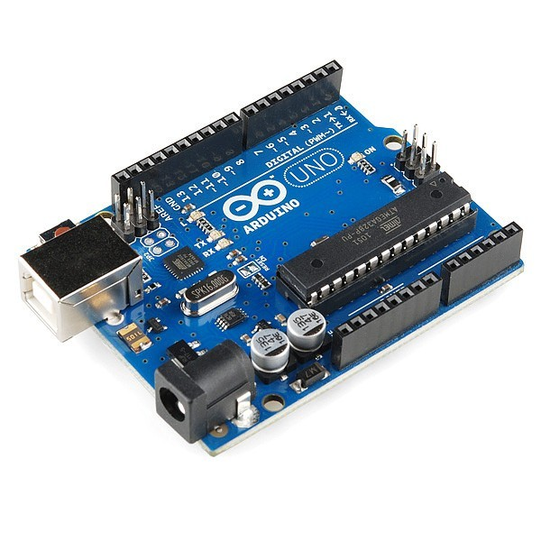

Arduino UNO R3 uses **ATmega328P microcontroller** as the main control and processing unit of the board. The Atmega328P has 32kB In-System Programmable Flash Memory, 1kB EEPROM, and 2kB internal SRAM.

The UNO board provides access to **14 Digital I/O pins (0-13 in above image)**. Of these 14 digital I/O pins, **6 pins** can be used as **PWM** **pins (pins 3,5,6,9,10 and 11)**. The PWM pins are indicated by ~ before the pin number on the Arduino UNO boards.

Digital pins 0 and 1 are the serial communication pins **RX** and **TX** respectively.

**6 pins** are available for use as **Analog input pins (A0-A5)**. The analog pins can be used as digital I/O pins as well if there is no analog input to be measured.

the R3 uses an ATmega16U2 for USB-to-serial conversion. The ATmega16U2 is programmed for USB-to-serial conversion. (up to R2, ATmega8U2 was used for USB-to-serial conversion, whereas the boards prior to UNO used FTDI USB-to-serial driver chips).

The UNO board can be powered through

* A USB cable.
* An external AC-DC adapter (output voltage of the adapter must be fixed and within the range of 7V to 12V). Adapter needs to be plugged into the power jack.
* A battery (Fixed voltage, the voltage must be in the range of 7V to 12V). Battery terminals must be connected between VIN and GND pins on the board.
* **Breadboard**

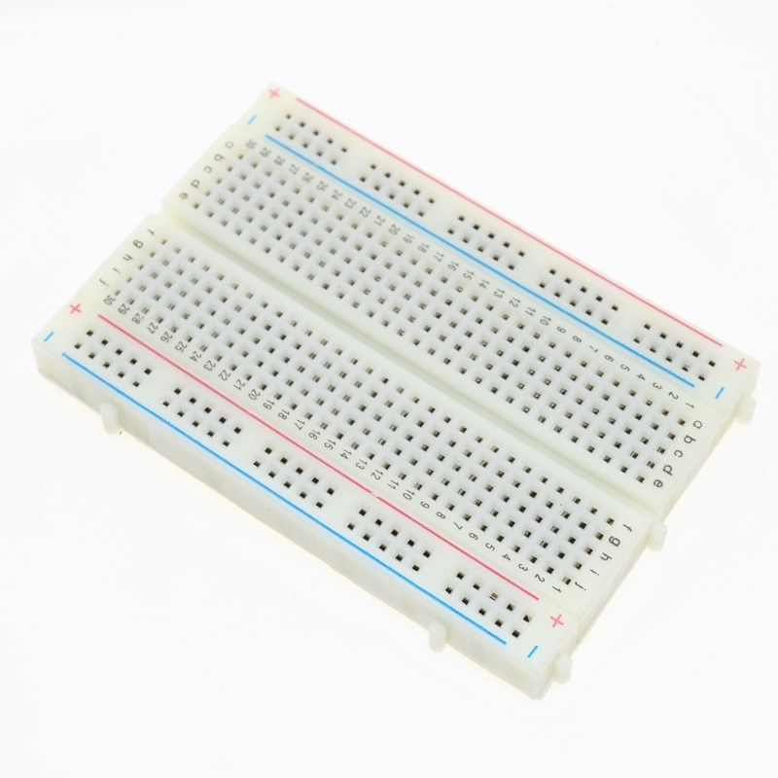

A breadboard is a solderless device for temporary prototype with electronics and test circuit designs. Most electronic components in electronic circuits can be interconnected by inserting their leads or terminals into the holes and then making connections through wires where appropriate.

The breadboard has strips of metal underneath the board and connect the holes on the top of the board. Note that the top and bottom rows of holes are connected horizontally and split in the middle while the remaining holes are connected vertically.

Breadboards have many tiny sockets (called 'holes') arranged on a 0.1" grid. The leads of most components can be pushed straight into the holes. ICs are inserted across the central gap with their notch or dot to the left.

Wire links can be made with single-core plastic-coated wire of 0.6mm diameter (the standard size), this is known as 1/0.6mm wire. I suggest buying a pack with several colours to help identify connections, red for +Vs wires, black for 0V, and so on.

Stranded wire is not suitable because it will crumple when pushed into a hole and it may damage the board if strands break off.

* **PIR Sensor**

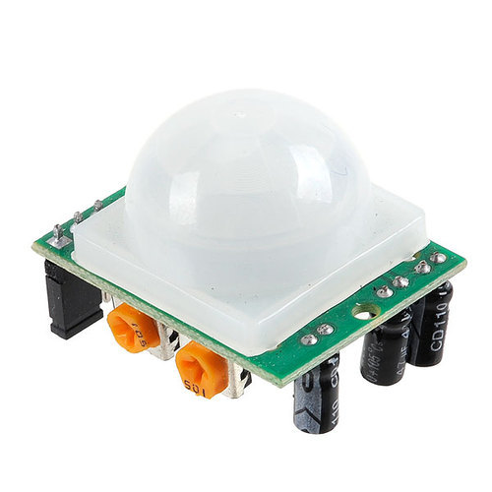

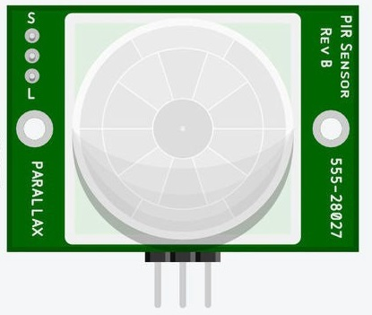

A passive infrared sensor is an electronic sensor that measures infrared light radiating from objects in its field of view. They are most often used in PIR-based motion detectors. PIR sensors are commonly used in security alarms and automatic lighting applications.

Generally, PIR can detect animal/human movement in a requirement range, which is determined by the spec of the specific sensor. The detector itself does not emit any energy but passively receives it, detects infrared radiation from the environment.

PIR sensors allow you to sense motion. They are used to detect whether a human has moved in or out of the sensor’s range. They are commonly found in appliances and gadgets used at home or for businesses. They are often referred to as PIR, "Passive Infrared", "Pyroelectric", or "IR motion" sensors.

Following are the advantages of PIR Sensors −

* Small in size
* Wide lens range
* Easy to interface
* Inexpensive
* Low-power
* Easy to use
* Do not wear out

Range of different PIR sensors:

* **Indoor passive infrared**: Detection distances range from 25 cm to 20 m.
* **Indoor curtain-type**: The detection distance ranges from 25 cm to 20 m.
* **Outdoor passive infrared**: The detection distance ranges from 10 meters to 150 meters.
* **Outdoor passive infrared curtain detector**: distance from 10 meters to 150 meters
* **Piezo Buzzer**

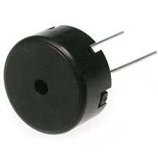

A piezo buzzer is a type of electronic device that’s used to produce a tone, alarm or sound. It’s lightweight with a simple construction, and it’s typically a low-cost product.

Piezo sounders contain a piezo electric vibration plate (also known as a piezo element) within a moulded case.  Sound is emitted when a voltage is applied and the piezo element inside the case vibrates.

Piezo buzzers generally use less current, have a higher sound output and wider operating voltage.

Simple, compact, and reliable, piezoelectric [audible sound transducers](https://www.americanpiezo.com/piezo-theory/whats-a-transducer.html) also called tone generators, or buzzers—can deliver a high sound output from a small (milliwatt) energy input. Emitted sounds range from soft hums to strident alarms. These devices are well suited for use in portable, battery powered equipment, and are employed in a wide variety of [products](https://www.americanpiezo.com/products-services.html), including timers, smoke alarms, games, telephone ringers, metal detectors, watches, automobile alarms, and many others.

The construction of a piezo ceramic buzzer greatly affects the level of the sound it emits and the cost of the device. Nodal support mounting minimizes mechanical restriction on the movement of the sound-producing mechanism, so the amplitude of the vibrations is highest. On the other hand, signal originating from beyond the nodal ring will be in antiphase with signal from the central part of the element, and can reduce the sound output. To prevent this interference, the housing must absorb all output from the periphery of the element.

* **Jumper Wires**

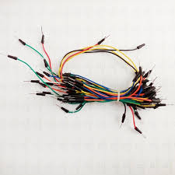

A **jump wire** (also known as jumper wire, or jumper) is an [electrical wire](https://en.wikipedia.org/wiki/Electrical_wire), or group of them in a cable, with a connector or pin at each end (or sometimes without them – simply "tinned"), which is normally used to interconnect the components of a [breadboard](https://en.wikipedia.org/wiki/Breadboard) or other prototype or test circuit, internally or with other equipment or components, without soldering.

Individual jump wires are fitted by inserting their "end connectors" into the slots provided in a breadboard, the [header connector](https://en.wikipedia.org/wiki/Pin_header#Header_connector) of a circuit board, or a piece of test equipment.

Jumper wires are used for making connections between items on your breadboard and your Arduino’s header pins.

There are different types of jumper wires. Some have the same type of [electrical connector](https://en.wikipedia.org/wiki/Electrical_connector) at both ends, while others have different connectors.

* **LED’s**

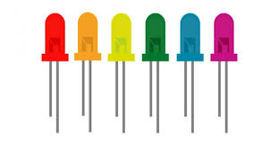

LEDs are diodes which are electronic devices that only allow current to go through them in one direction. This means that LEDs (and other diodes) have positive (+) and negative (-) sides to them. For an LED to work it needs to be connected to a voltage source with the correct side. The voltage supply side of the diode is the positive (+) side, this is called the anode. The negative side is called the cathode.

Because diodes are made of semiconductor material, they have a very specific voltage where they will turn on. If the supply voltage you’re using is more than then turn on voltage, you need a resistor between one of the LED leads and the connection to either **GND** or the supply voltage.

* **Resistor**

Resistor is an electrical component that reduces the electric current.

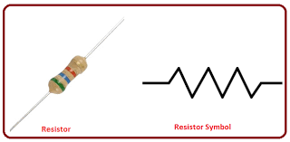The resistor's ability to reduce the current is called resistance and is measured in units of ohms (symbol: Ω).

To make sure that the LED isn’t damaged by too much current, the connection between it and the voltage supply needs a resistor.

In smaller-value resistors, designed for lower-power circuits, the copper winding is replaced by a spiral pattern of carbon. Resistors like this are much cheaper to make and are called **carbon-film**. Generally, wire-wound resistors are more precise and more stable at higher operating temperatures.

* 1. **Software Requirements**
* **Tinkercad**



Tinkercad is a free and easy-to-use application for 3D design, electronics and coding.

Autodesk's Tinkercad is one of the most popular classroom tools for creating simple designs from scratch, quickly modifying existing designs. It’s a free online 3D design program that you can use in your web browser without downloading any software. Tinkercad is extremely intuitive and easy to use, and has built-in Lessons to help you learn the ropes, making it perfect for beginners both young and old.

Additionally, the software enables to add electronic circuits to 3D designs in order to create objects with light and movement. The end result can even be simulated on the software to check how the components will respond in real life.

Tinkercad Circuits allows anyone to virtually create and program Arduino projects without the need for physical hardware.

* **Java (Language)**



Java is a high-level programming language originally developed by Sun Microsystems and released in 1995.

Java is a high level, robust, object-oriented and secure programming language.

Java runs on a variety of platforms, such as Windows, Mac OS, and the various versions of UNIX.

**CHAPTER 4**

**4.1 Block Diagram**

Transmitter

Obstacle

Arduino

PIR Sensor

Power Supply

Buzzer

The block diagram of the OBSTACLE DETECTION SYSTEM is shown above. The circuit comprises of an Arduino UNO board, a pir sensor, a RF transmitter and receiver and buzzer. You can power the Arduino board using a 7V to 12V wall wart or plug-in adaptor or a separate 9-12V battery. This Arduino board is connected to the pir sensor which does the important job. After the sensors collect the data, it sends it to the Arduino board for further use. The buzzer is connected to the Arduino which displays the collected data in the form of output. For carrying out this function certain code or operation should be saved. So, the whole process takes place with the help of these components.

**4.2** **Circuit Diagram**

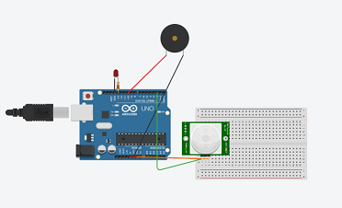

In this circuit diagram we see that Arduino is connected wirelessly using RF transmitter and receiver. A pir sensor and RF transmitter are connected to the arduino. This Arduino will be powered by a battery. This Arduino board is connected to the pir sensor which does the important job. After the sensors collect the data, it sends it to the Arduino board for further use. The buzzer is connected to the Arduino which displays the collected data in the form of output.

**CHAPTER 5**

**5.1 Working**



In the working model, we have basic 5 components.

1. Arduino

2. Transmitter

3. PIR sensor/receiver

4. LED

5. Buzzer

The sensor is connected to the Arduino board to send and collect the data.

Arduino board works on the data and further. The Arduino boards are programmed to detect the obstacle depending on the available pir sensor.

The working takes place in following steps:

Step 1: The pir sensor is connected to the Arduino board.

Step 2: The results of the sensor are send to the Arduino board for further functioning.

Step 3: The battery connected Arduino board checks the condition of sensor. If it is high, then it will send the signal to the arduino. Some processing will take place and this data will be transmitted. Using the RF transmitter. At the other end an RF receiver will capture the data and process it

Step 4: The arduino which will then detect the obstacle

Step5: Once it is been detected it will then be shown with the help of a sound from the buzzer.

This process goes on continuous every day and provides information

about the obstacles. Also, it saves human efforts and time.

**CODE**

int ledPin = 13;

int inputPin = 2;

int pirState = LOW;

int val = 0;

int pinSpeaker = 10;

void setup()

{

pinMode(ledPin, OUTPUT); // declare LED as output

pinMode(inputPin, INPUT); // declare sensor as input

pinMode(pinSpeaker, OUTPUT);

Serial.begin(9600);

}

void loop()

{

val = digitalRead(inputPin);

if (val == HIGH)

{

digitalWrite(ledPin, HIGH); // turn LED ON

playTone(300, 160);

delay(150);

if (pirState == LOW)

{

// we have just turned on

Serial.println("Motion detected!");

// We only want to print on the output change, not state

pirState = HIGH;

}

}

else

{

digitalWrite(ledPin, LOW); // turn LED OFF

playTone(0, 0);

delay(300);

if (pirState == HIGH)

{

// we have just turned off

Serial.println("Motion ended!");

// We only want to print on the output change, not state

pirState = LOW;

}

}

}

// duration in mSecs, frequency in hertz

void playTone(long duration, int freq)

{duration *= 1000;

int period = (1.0 / freq) * 1000000;

long elapsed_time = 0;

while (elapsed_time < duration)

{

digitalWrite(pinSpeaker,HIGH);

delayMicroseconds(period / 2);

digitalWrite(pinSpeaker, LOW);

delayMicroseconds(period / 2);

elapsed_time += (period);

}

}

**5.2 Result**

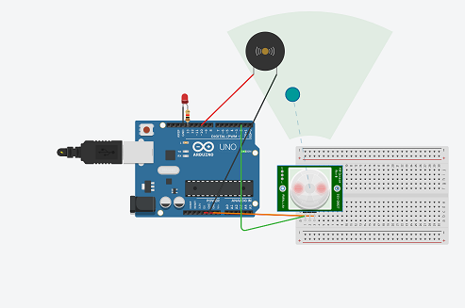

Figure above represents results of our experiment in the form of the overall representation of our tested OBSTACLE DETECTION SYSTEM based on Arduino board microcontroller and sensor technology. As it can be concluded from the picture above, the system has been designed and tested successfully in a successful manner. Also, functionality of the system, as well as the overall behaviour. As a result of our observation, we noticed that this system led to an efficient management. The arduino board continuously sent signals that could be interfaced with the obstacle so as to avoid it.

**CHAPTER 6**

**6.1 Conclusion**

The system provides with several benefits and can operate with less manpower. The system raises an alert when the obstacle is detected. Due to this information the obstacle can be successfully avoided. This is a very efficient system which can be used in an indoor environment. It also saves valuable time. Thus, the system is efficient and compatible to the changing environment.

**6.2 Bibliography**

|  |  |
| --- | --- |
| |  | | --- | |  | |

* <https://www.ijert.org/research/an-iot-based-obstacle-detection-and-alerting-system-in-vehicles-using-ultrasonic-sensor-IJERTCONV5IS20002.pdf>
* [https://sci-hub.se/http://ieeexplore.ieee.org/document/6385638](https://sci-hub.se/http:/ieeexplore.ieee.org/document/6385638)
* [https://sci-hub.se/https://iopscience.iop.org/article/10.1088/1757-899X/152/1/012064/pdf](https://sci-hub.se/https:/iopscience.iop.org/article/10.1088/1757-899X/152/1/012064/pdf)
* <https://electronicsclub.info/breadboard.htm>
* <https://www.tutorialspoint.com/arduino/arduino_pir_sensor.htm>
* <https://www.americanpiezo.com/standard-products/buzzers.html>
* <https://www.exploringarduino.com/parts/jumper-wires/>
* <https://makecode.adafruit.com/learnsystem/pins-tutorial/devices/led-connections>